Nurse To Go

A novel approach to home health care using a suite of tools and software

Hastimal Jangid, Jordan Larson, & Mohamoud Ali

University of Missouri Kansas City Department of Computer Science and Engineering

CS5543 – Real Time Big Data Analytics – Dr. Yugyung Lee

Kansas City, MO

*Abstract*—The purpose of the present study is to investigate machine learning methodologies as they relate to robot-assisted home health care. Our aim is to demonstrate an optimized approach to enabling patients recovering from knee surgery using machine learning, natural language processing, and internet of things components

Keywords—machine learning; natural language processing; internet of things; robot; naïve bayes, decision tree, k-nearest neighbor, sentiment analysis

# Introduction

# In the United States, patient noncompliance is a very real issue. According to many studies, noncompliance is often caused by lack of proper patient education. Type I and Type II diabetes patients, for example, generally have a compliance rate of 39 and 37%, respectively [1]. This is a shocking statistic, and patients with diabetes could benefit immensely from an accountability partner.

Circa 2010, the “Revolving Door Syndrome” was starkly addressed by many authors. One, in particular, cited a study that revealed “One in eight Medicare patients were readmitted to the hospital within 30 days of being released after surgery in 2010, while one in six patients returned to the hospital within a month of leaving the hospital after receiving medical care.” [2] Certainly there are other culpable parties causing one in six patients to require readmission, but a large part of this issue is patient noncompliance.

## Motivation

The purpose of the present study is to develop a system of physical and virtual components that will enable a patient to nurse themselves back to good health as they recover from a recent surgery. The system will be given to the patient as they are discharged after a surgery and it will be configured to contain data on that particular patient’s discharge orders and plan of care.

## Significance

This project is significant and novel in that it harnesses several technologies to communicate with a patient, to encourage a patient to adhere to their plan of care, and, using machine learning methodologies, it is expected the project will improve patient compliance.

Machine learning algorithms have evolved rapidly during the past decade. Gesture, image, voice, and other types of recognition are all made possible by these breakthroughs. Naïve Bayes has been ubiquitously used in gesture recognition [3], and we plan to compare results obtained using Naïve Bayes, k-nearest neighbor, decision trees, and random forests.

## Objectives

During the course of this study, our primary focus was to develop features that would be relevant to patients recovering from knee surgery. The Nurse To-Go (NTG) system features were tailored to address several needs many patients desire when recovering from a surgery.

Specifically, our team seeks to design an early implementation simulating the discharge of an orthopedic surgery patient. Patients involved will have recently received a knee surgery including one of the following procedures: total knee replacement (TKR), bilateral total knee replacement (BTKR), meniscus repair, and anterior cruciate ligament repair.

# Problem analysis and proposed solution

## Problem Statements

* Monitor recommended exercises as well as coach the patient to 1) ensure all recommended exercises are performed, 2) exercises are performed appropriately, and 3) remind patient to do their exercises
* Track health metrics including nutritional intake, steps taken, hours of sleep, and other exercises
* Provide text-to-speech and speech-to-text capabilities for the system

In order to monitor recommended exercises, a Texas Instruments (TI) Sensor Tag device was used. Machine learning algorithms were applied and compared in order to evaluate the best approach for us to use to detect when a patient is performing a specific type of exercise.

To track nutritional intake, speech-to-text was used and the patient simply tells the robot what they had for a given meal. The robot will verify that the text was accurate and then the meal is stored in a MongoDB collection. To track steps taken, the same TI Sensor Tag can be used to gather data on steps taken throughout the day.

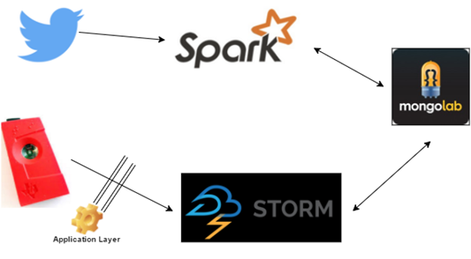

Figure 1 - NTG Data Architecture

The patients the robot will serve have a variety of procedures they are recovering from, as well as a variety of diets, target ambulatory distance, and recovery time. The diets the application will initially support are diabetic, heart healthy, and low carb. In the future, diets that will be supported will be gluten free and the following classifications of vegetarian diets:

* Vegan - no animal products or by-products
* Lacto - no meats but milk is okay
* Ovo - no meats or milk but eggs are okay
* Lacto-ovo - milk and eggs are okay
* Pollotarian - only poultry or fowl meats
* Pescatorian - only fish and seafood meats
* Flexitarian - infrequent meat consumption

The reason we are accounting for a large number of diets is that nutrition is very important to patient recovery. Patients with specific dietary needs will be more inclined to use the app if their needs are taken into account. The hospital staff will be able to set care guidelines in the software and the robot will communicate to the patient what they have achieved during the day as well as what they should still attempt to do. Care plan recommendations will include taking their medications, ambulation, meals, and sleep duration. Heart rate and other vital signs monitoring are future goals for the app.

## Algorithms – Machine Learning

The machine learning algorithms used will be described in this section, along with Natural Language Processing (NLP) used to process text so that it can be used in sentiment analysis to derive degree of positive or negative sentiment. The algorithms are described, but technical details of training events and specifics involving probability are out of scope of this paper.

1. Naïve Bayes – use training data, and based on previous data, calculate posterior probability that a classification “fits” with a certain event.
2. Decision Trees (ID3 algorithm)
   1. Calculate entropy of every attribute using data set *S*
   2. Divide *S* into subsets where entropy is smallest (provides most information gain)
   3. Create node with the selected attribute
   4. Recursively call algorithm until the set *S* has no attributes remaining
3. Random Forests
   1. Create *n* decision trees using original decision tree data
   2. For each tree data set, instead of creating a decision tree based on entropy, randomly select attributes at each node based on a subset of the original predictors.
   3. Determine the overall majority from all created trees.
4. K-nearest neighbor (KNN)
   1. For each object other than the object being inspected, create a subset of *k* items that are ‘closest’ to the object inspected.
   2. Then assign a class to the object

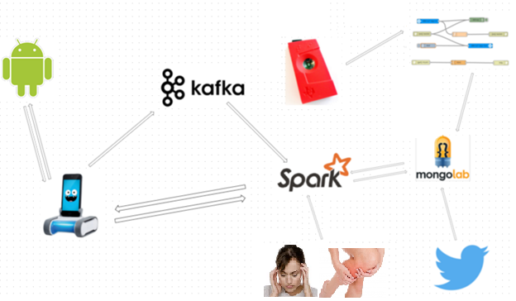

Figure 2 - NTG System Architecture

## Algorithms – CoreNLP/Sentiment Analysis

Stanford CoreNLP Part of Speech (POS) tagging is used to determine the context of a certain word. First, a text input from the patient is input into the NLP pipeline and sentences are split and tokenized. The tokens are then assigned POS tags and used in the sentiment analysis (SA) mechanism in CoreNLP. A “recursive tensor neural network” is used in order to obtain SA results.

## Analytical Tasks

The primary analytic task we performed is motion recognition using machine learning algorithms. We want the patient to perform their exercises in a controlled setting where the robot can tell the patient that they just performed their procedure wrong. Before the project scales out, we will have three gestures the robot will be trained in recognizing. All of these gestures are recommended for total knee replacement recovery. They include the following:

# implementation and evaluation

How are we preparing our RDD and algorithms and etc.

## Design of Big Data Analytics Server

Twitter data will be imported using Twitter's real-time streaming API and normal API with Spark to access tweets by hashtag, content, and more. The data will be obtained from Twitter and then stored in MongoLab. MongoLab will store the Tweets so that they can be analyzed and used by other parts of the program later.

## Proposed Software Architecture

As proposed system is to monitor patient's health and real-time activity, so here patient(Android) can talk with health assistant(NTG) and simultaneously can send symptoms image to Spark where SparkML will process algorithms and send result to physician via Twilio service. The patient’s regular exercises like leg-slide, knee-bending, and heel-slides are done through machine learning model training.

Figure 1 depicts our system implementation using big data analytics technologies including Spark, Storm, and MongoLab.

|  |  |  |
| --- | --- | --- |
| Excercise | Description | Image *[9] |
| Leg Slides | This is performed sitting on your back. Keeping your knee pointed upward, move one leg away from your body parallel with the floor to about 40°, or until uncomfortable. Then return leg to its starting position. |  |
| Knee Bending | Sitting in a chair, bend one leg until you have reached full active range of motion. |  |
| Heel Slides | This is performed sitting on your back. Keeping your knee pointed upward, bend your knee and hip while sliding your foot towards your buttocks. Bend until active full range of motion is reached. |  |
| Lying Kicks | This is performed sitting on your back. Roll up a blanket or find another round object that can rest beneath your knee. With the object resting beneath your knee, straighten your leg until it is fully straightened, or until uncomfortable. | Inserting Picture... |

Table 1

## Design of the Overall System Architecture

Using the mobile client, the patient is able to talk to NTG for assistance after being discharged from hospital as well as directly talk with Spark for machine learning on symptoms’ sent through images from patient to system. As seen in Figure 2, Spark receives images sent from the patient and performs machine learning techniques on those images to predict what is going wrong with patient and later send a report back to doctor using Twilio service REST API.

## Design of the Mobile Client

Our mobile client is a simple Android UI that provides the ability to create a socket connection between the RoboMe robot (with attached iPhone/iOS device) and the Android device (Figure 3). Our UI also includes a speech-to-text view where the text is processed by our data layer and the results are then delivered to the iOS device (Figure 3 and 4), where NTG can relay the results to the patient.

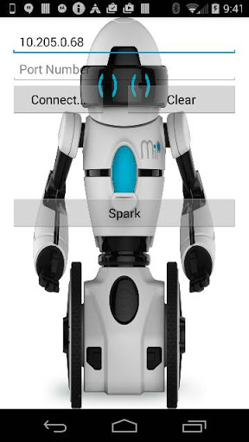

Figure 3 - RoboMe robot UI with socket connection and option to submit speech-to-text through Spark

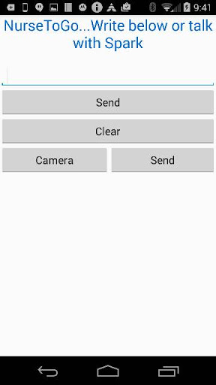

Figure 4 – UI view for sending data to Spark

## Existing Open Source Projects/Services Used

* Node-Red IoT/Bluemix
  + Using the TI sensor tag, the system collects the patient’s real-time activity data and, using spark machine learning algorithms, classifies what kind of exercises patient is doing. NTG uses Naïve Bayes, KNN, Random Forest, Decision tree algorithms with the highest accuracy more than 98 % in terms of prediction.
* Twilio API
  + After getting symptom’s image classification with machine learning, NTG can send report to doctor, in case of requirement, using Twilio’s service API.
* Weather API
  + If the patient wants to go outside or somewhere else for walk, the patient can check if the current outside weather is not suitable for patient. Here, the weather API provides details about current temperature, weather conditions and daily forecast.
* Twitter API
  + The patient is able to view health-related current tweets after doing sentiment analysis with CoreNLP API. Twitter live streaming can be helpful to see latest trend on healthy food and nutrition to speed surgical recovery.

Besides the above API’s, we plan to use those in the following table:

|  |  |
| --- | --- |
| **API** | **Description** |
| FatSecret Platform | Nutrition Facts, taking care of diet and analysis |
| Edamam | Nutrition Facts, Diet Type, and Meal Recommendations |
| NDB | Nutrition Facts |
| Nutritionix | Not sure if we will use this yet. NXQL - Specific querying language allows for complex queries made on-the-fly |

Table 2 - External Nutritional APIs Investigated

# Results and evaluation

## Data Collection and Data Sources

The NTG system is a virtual assistant that receives data feeds from multiple sources.

1. Sensor data for activity recognition: We have used TI Sensor Tag (ST) to capture accelerometer data while physically performing one of three distinct exercises and when resting. The ST is connected to a Mobile App provided by its vendor. We have set up the Mobile App to connect to a Node-RED that is deployed in the IBM BlueMix cloud environment. The incoming accelerometer data is combined with activity descriptor.

For example, the ST sends JSON object as shown in Figure 5. We have intercepted the JSON feed from the ST device and injected new value indicator for each activity as it being performed. This was done to later use this value as a class category during training. Figure 5 shows the new value injected in the feed. Figure 6 shows the Node-RED nodes that accepts feed from the ST using MQTT protocol, injects the exercise indicator value and posts that to a MongoDB storage.

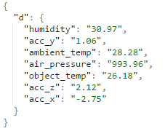

Figure 5 – TI Sensor Tag JSON format

The activity indicator inject is, to the best of our knowledge, a novel idea for sensorTag activity classification. Prior studies used clustering algorithms such as kMEANS. This type of data was hard to train using classification algorithms since that would entail using a training dataset that includes activity class. Our technique allows us to initiate a particular exercise and inject its indicator for use as classification modeling.

For training purposes, we have used MongoExport utility to fetch all training data in CSV format. An ARFF file was then constructed. Our ARFF file contains four attributes one of which is the class attribute and the remaining three the (x, y, z) data for the accelerometer.

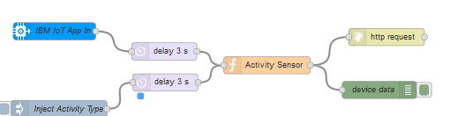

Figure 6 – Node-RED architecture of TI Sensor Tag data handling

1. Patient speech: NTG accepts patients spoken language as input to accept commands as well as queries or questions.

## Machine Learning Algorithmic Performance

We collected data in two formats – binary and multi-class. The metrics we measured included the overall accuracy, precision, and recall on 2,489 instances of data for each of the machine learning algorithms – namely, Naïve Bayes, K-nearest neighbor, random forest, and decision tree. The results are shown below in Table 3.

|  |  |  |  |  |  |
| --- | --- | --- | --- | --- | --- |
| Algorithms | Data Type | Accuracy (%) | Precision (%) | Recall (%) | Instances |
| Naïve Bayes | Binary format | 77.54 | 78.7 | 77.5 | 2489 |
|  | Multi-class | 94.94 | 95.1 | 94.9 | 2489 |
| KNN | Binary format | 96.38 | 96.4 | 96.4 | 2489 |
|  | Multi-class | 96.35 | 96.4 | 96.3 | 2489 |
| Random Forest | Binary format | 96.75 | 96.8 | 96.7 | 2489 |
|  | Multi-class | 96.54 | 96.7 | 96.5 | 2489 |
| Decision Tree | Binary format | 96.10 | 96.2 | 96.1 | 2489 |
|  | Multi-class | 96.14 | 96.3 | 96.1 | 2489 |

Table 3 – Machine Learning Algorithmic Performance

# Discussion and future goals

We did not anticipate such low performance of the binary Naïve Bayes algorithm and we did not anticipate such a high level of accuracy from the remaining algorithmic types.

## Outcome of the Present Study

Our findings are significant because we were unable to find any other studies investigating similar aspects of medicine. Accelerometer data has been used previously to prevent falls (primarily in geriatric patients [5]), monitor posture in stroke survivors [6], and gather data on hip replacement surgery patients [4]. The last study mentioned proposes an intelligent system that interacts with a patient after they have received a hip replacement surgery. It was surprising to find such a close study to the one we propose, but the focus of this paper is on monitoring, storing, and aggregating collected data on the patients. They did not take the research as far as helping the patient perform their exercises while recovering.

## Future Goals

We expect that this project will be scalable to other exercises. Using machine learning techniques, we can use this system to help patients with their physical therapy and recovery. We can add more features to the system in order to make it more user friendly.

The present study is more of a proof of concept, but if this was used in a realistic situation, we would create a robust user interface, expand on all the aforementioned features, and we would begin to include new features. Some additional features we discussed include adding the ability to have NTG track the patient’s location in real time so they can exercise outside and have their route monitored. Then the patient can improve on their distance traveled, rate of speed, and more. Image and sound recognition could be significantly improved to allow NTG to make recommendations to the patient based on their appearance, how their voice sounds, and even monitor gait. Our results show promise in providing patients with several ways to improve their surgical recovery outlook.

##### References

1. Delamater, Alan M. "Improving patient adherence." Clinical diabetes 24.2 (2006): 71-77.
2. The Revolving Door: A Report on US Hospital Readmissions. Robert Wood Johnson Foundation, 2013.
3. Ashbrook, Daniel, and Thad Starner. "MAGIC: a motion gesture design tool." Proceedings of the SIGCHI Conference on Human Factors in Computing Systems. ACM, 2010.
4. Jimenez Garcia, Juan, et al. "ESTHER: a portable sensor toolkit to collect and monitor total hip replacement patient data." Proceedings of the 3rd ACM MobiHoc workshop on Pervasive wireless healthcare. ACM, 2013.
5. Liu, Chien-Liang, Chia-Hoang Lee, and Ping-Min Lin. "A fall detection system using k-nearest neighbor classifier." Expert systems with applications 37.10 (2010): 7174-7181.
6. Arteaga, Sonia, et al. "Low-cost accelerometry-based posture monitoring system for stroke survivors." Proceedings of the 10th international ACM SIGACCESS conference on Computers and accessibility. ACM, 2008.
7. Twilio API - <http://www.twilio.com/>
8. Weather API - <http://openweathermap.org/ap>
9. Knee Exercises After Total Knee Replacement -[http://www.healthline.com/health-slideshow/total-knee-replacement-surgery-excercises-after#5](http://www.healthline.com/health-slideshow/total-knee-replacement-surgery-excercises-after%235)
10. Google Text-to-Speech - <https://www.google.com/intl/en/chrome/demos/speech.html>
11. “Edamam - Eat Better” - <https://developer.edamam.com>
12. USDA’s National Nutrient Database for Standard Reference (NBD) -<http://ndb.nal.usda.gov/ndb/doc/index>
13. “FatSecret Platform” - <http://platform.fatsecret.com/api/>